LEGO MINDSTORM

Following a line edge

# Knowing the Blocks

## Move – Steering

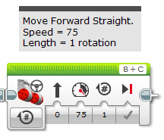

Left Motor Port

Right Motor Port

Direction of Movement

Speed of Movement

Brake when finished

Number of Rotations/Degrees/ Seconds

MENU

## 

Move the robot forward in a straight line using at least 3 different speeds.

Use the button on the robot to run the program on the ground.

## 

Turn the robot left then right in the 1 program.

## 

Use a loop to make the robot complete a continuous circle.

## 

Use a switch, detecting the different light value to follow the line.

## 

Use another switch to get past the yellow obstacles.